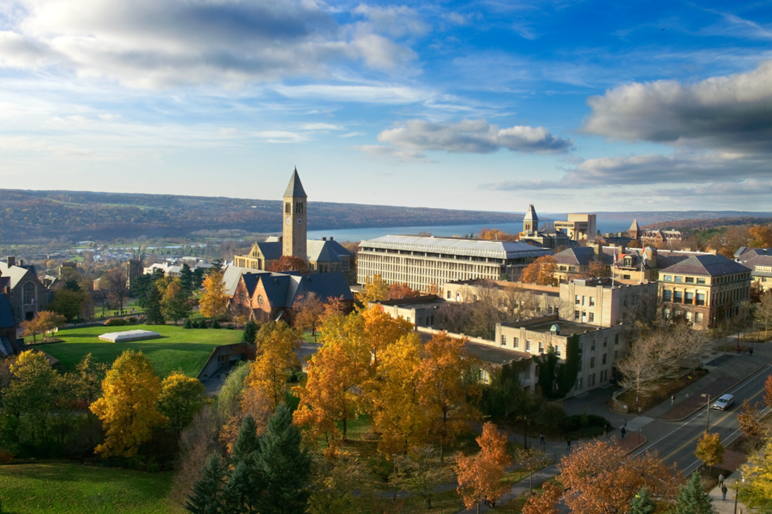

Cornell Club of Sarasota-Manatee 2015-2016 Events

Learn*Serve*Socialize

Thursday, October 15  Zinck's Night  The Field Club  Socialize  Enjoy the sunset  Thursday, November 12  Luncheon  Dolly Jacobs-Reis/Pedro  Reis: Circus Sarasota  Thursday, December 3  Tour of Sarasota County  Technical Institute  Find adult enrichment  Classes for almost every  interest one could have  Luncheon optional  at The Bistro  Thursday, December 10  Luncheon  Dr. Donal O’Shea  President of New College  Class of 1980 – 2015  Watch your emails  and the club  Website for events | Saturday, January 9  Cornell Cares  “Hug a Puppy” and  Tour the Southeastern  Guide Dog Campus  Thursday, January 14  Scholarship Luncheon  Dr. Alan Mathios  Dean of the College of  Human Ecology  Thursday, February 11  Luncheon  Steven High  Executive Director  The Ringling  Thursday, February 25  Private tour of Ringling  College of Art + Design  Computer Animation Lab,  Letterpress Studio, Motion  Design  Luncheon optional | Wednesday, March 9  Luncheon  Dr. Christopher Dunn  Director of Cornell  Plantations  Tuesday, March 22  Backstage private  tour of the Sarasota Ballet  Thursday, April 14  Luncheon  David Verinder  CEO of Sarasota Memorial System and Marguerite Malone, Chair of the Board  of Directors  Thursday, May 12  Red and White Luncheon  Rich Odell  Headmaster  IMG Academy  Support  Our Scholarship Fund

